Webpage: Looking for an alternative to DISC?

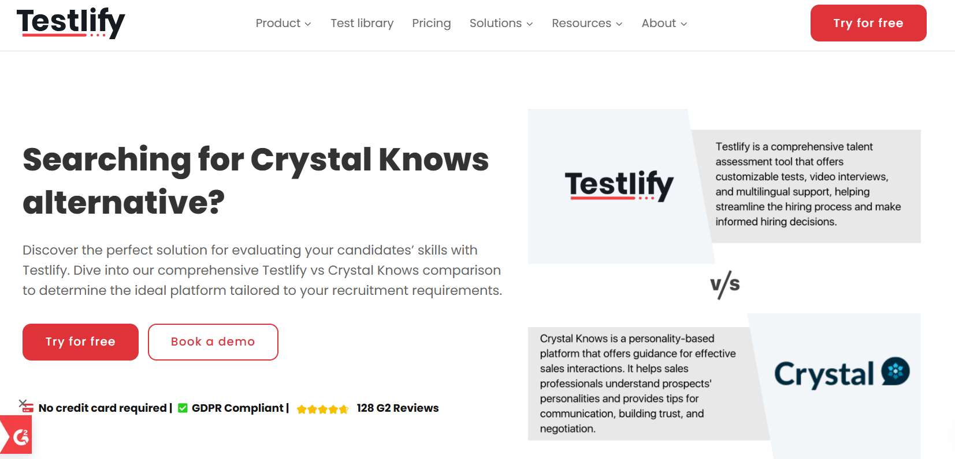
Insert Book a call and download a sample profile CTAs in hero

Copy for this hero image:
C-me:
C-me offers one of the most personalised and cost-effective approaches to personal, team and organisational development in the learning and development space. We have shifted the focus of workplace psychometric tools from fixed ‘personality types’ to a more useful focus on ‘adaptable behaviours’. C-me is designed for practical application in busy working environments.
DISC
​DISC is a profiling system that also applies colours to behaviours but more often refers to them as ‘personality profiles’. It focusses on observable behaviours and communication styles. It gives insights into how people respond to challenges, interact with each other, and approach tasks. It is less flexible than C-me. There are many different suppliers of DISC.

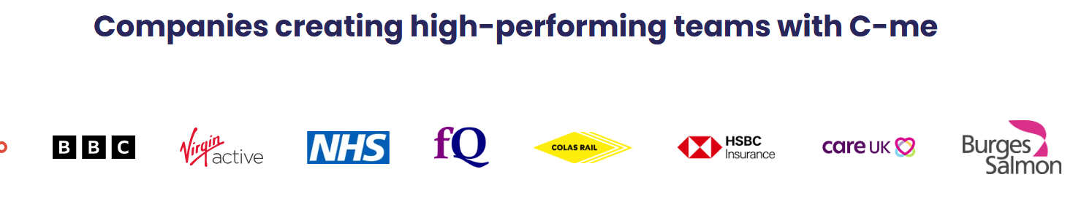

Why look for a DISC alternative?

Performance. User experience.
There are many different suppliers of DISC and some spell it in different ways to distinguish their product. There are, therefore, many different pricing structures. To be most helpful, in this comparison, we will focus purely on the differences and similarities of the C-me and DISC tools.
Essentially, C-me was designed for application in busy working environments. C-me is a more modern, powerful but simpler tool, which is more reflective of actual human behaviour, is easier to adopt and remember, therefore more effective in the workplace.

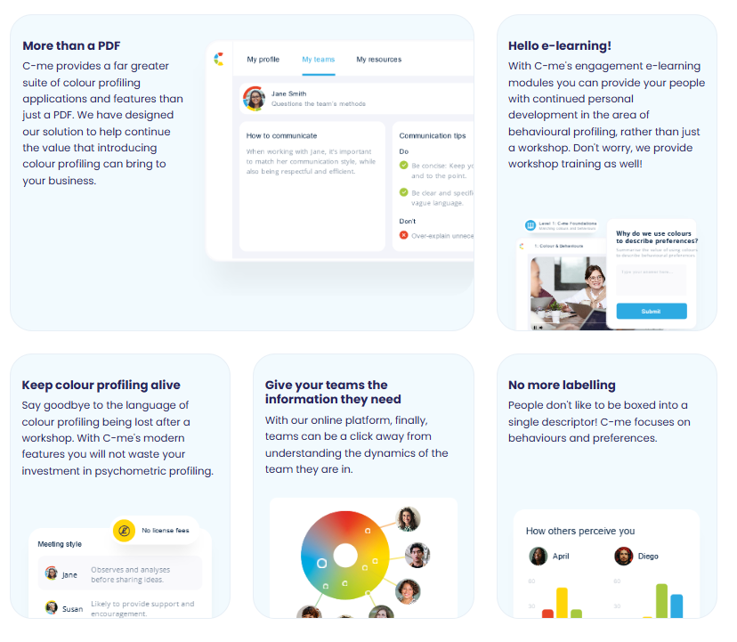
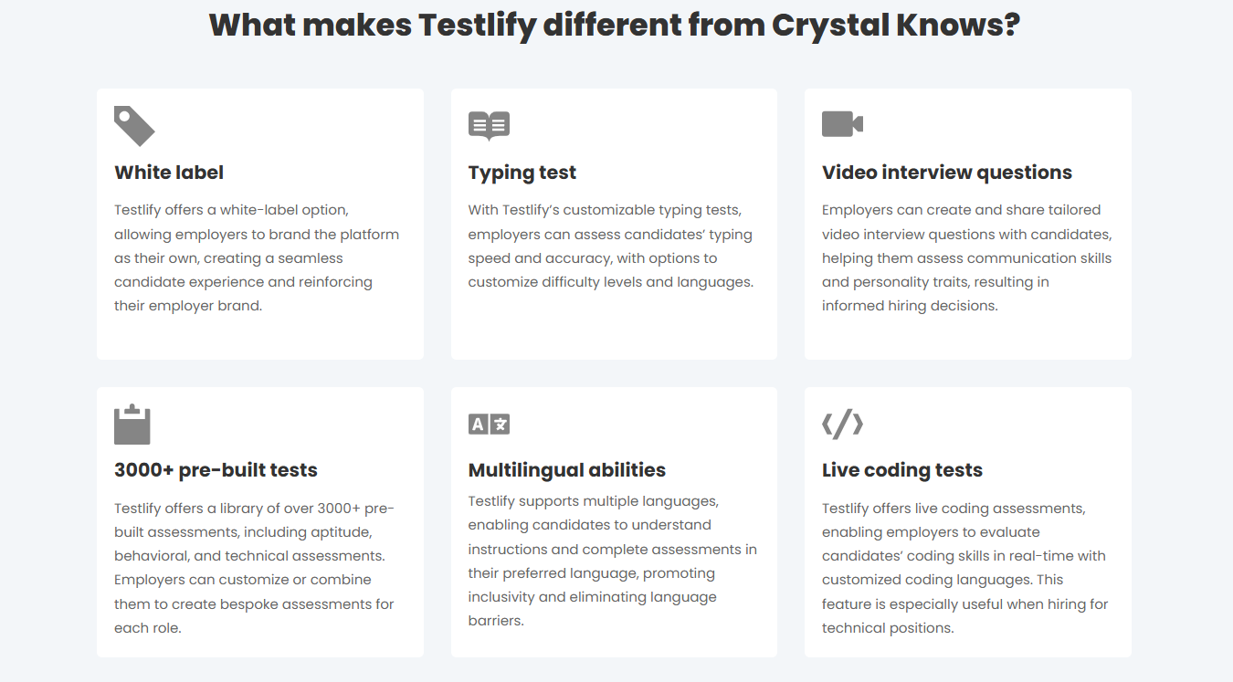

Please turn these points in to something that looks like the above graphics

What makes C-me different from DISC?

- No more labelling – No one likes to be boxed into a single descriptor. We are more complex and organisations need a tool to more accurately reflect how we change and develop at work. C-me focuses on how a person’s behaviours and preferences flex in different circumstances. We reveal when this might happen and how to plan for it.
- Faster to learn and more memorable – There is no need to master a complex system in order to remember your own profile and even those of everyone you’re working with. C-me can bring teams together from day one in any industry and context, because it’s designed to be faster to learn and effective immediately.
- Take charge of how you use C-me - Add your brand on the assessment, on the report, on the platform, on the workshop material. Take the C-me material and integrate it into your existing tools. We provide the tools for you to make it work for you.
- A more user-friendly, interactive platform for all C-me activity - view your report, tailor it, share it, and view the team wheels you’re a part of, work through coaching questions, and prepare for meetings by viewing the reports of anyone in your organisation. Access our e-Learning tool and app add-ins. One place to access C-me.
- Jargon free statements – We use more updated language in our report so that our reports speak directly to the user. You can even select your preferred pronoun.

How C-me and DISC compare

DISC

These images of the DISC wheel are just some of the ways that suppliers represent the DISC tool and a person’s profile. There are many more variations and in varying levels of complexity.

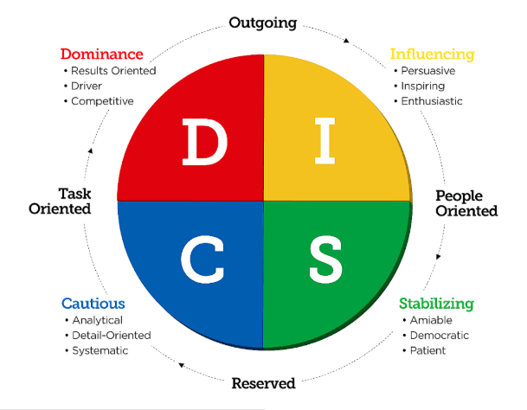

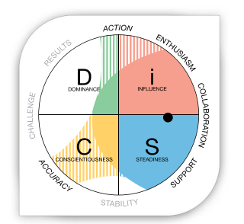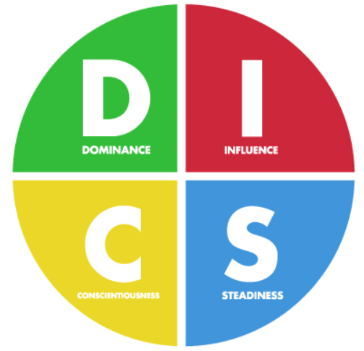
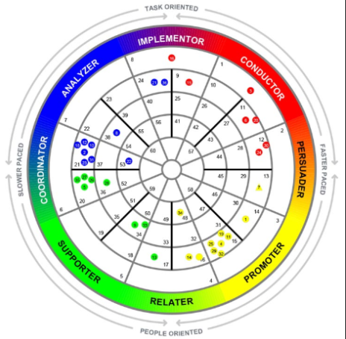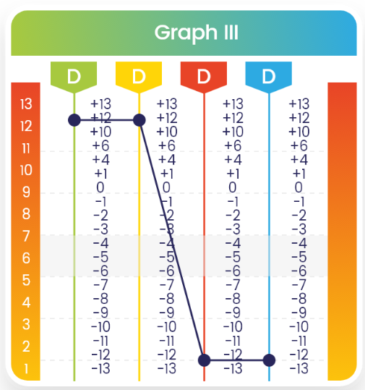

C-me

You’ll notice that we have stripped off all the rigid letters and numbers, and blended the colours on the wheel. This visually communicates the fact that people are a blend of all the preferences. Behaviour changes and people can move around the wheel in different roles.
We don’t ask responders to remember numbers and their according categories. Instead, we simply encourage people to learn the four colours of the wheel and what they stand for. We ask that users simply remember their top two preferred colours -not one but two, again to emphasise that people are a blend. A person’s profile is not stuck to one inflexible category. We do not box people in. We encourage flexibility and growth. This emphasises that none of us are one static category, we flex between colours depending on the circumstances we’re in.
We also provide two bar graphs to reflect a person’s more conscious behaviour – their ‘adapted profile’ – which we often observe about people at work, and their less conscious behaviour – their ‘natural profile’ – which we often observe about people in their homelife, and most interestingly, when they are under stress at work. This information is presented in separate graphs to keep the colour wheel uncluttered and more user-friendly.

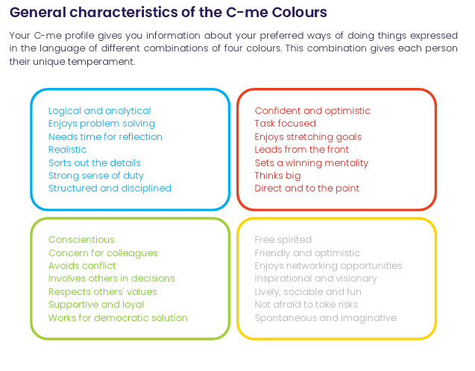
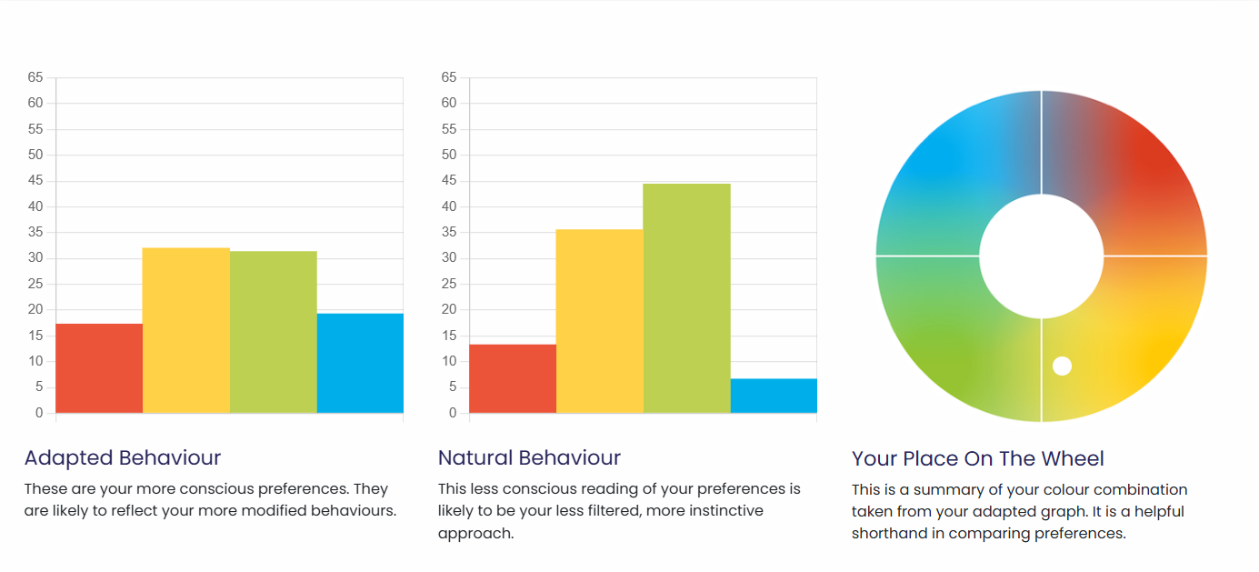

Primarly, our tools differ most noticbly in our approach to people. The understanding that people change and develop over their career, is baked in to the core of C-me. This is reflected in the C-me colour wheel that blends colours (we have removed letters and numbers that box people in). We also teach the concept of ‘flexing’ to reflect how people adapt to their environments. Most importantly, people can be trained to do this more effectively, to become better team members and leaders.
The DISC profile labels users with fixed categories that, even though it is often claimed people are a mix of all four, is contradicted by language such as being “typed” in one category. The fundamental belief that a profile is pretty much set for life is communicated in the language that comes with the tool – “I’m a D” for example.

Client quote
After 15 years working with other psychometric tools, C-me offer such a refreshing and much more applicable profile focused on adapted behaviour rather than defining a type.

Paul McGowran,Managing Director, Seek First Ltd

What are the similarities:
- Both are based on Jungian psychology.
- Application of colour to Jungian quadrants​ and both use a colour wheel.
- Both use preference indicators​ in the questionnaire – i.e. we ask people to rate themselves and their own preference.

CTA: Take a 3 min tour of C-me

Client testimonial
“Getting busy people working in a client driven commercial environment to free up time for their CPD is pivotal, and where C-Me is worth its weight is in how accessible and colloquial it is. It allows us to use it as a shared language (and subsequent understanding) to improving collaboration by understanding each other's preferences.” Gavin XXX from Burgess Salmon

Client testimonies of C-me’s accreditation

I would definitely recommend the accreditation. It was delivered in a clear, concise and friendly way that was easy to understand. There was room for discussion and time to reflect which was really valuable.- Claudia Shaw- The Kings Trust
Fun, easy to understand, flexible/ adaptable tool to many purposes, inclusive approach- Stephanie Lascaud- Q5
We have developed a short, intensive accreditation, spread over two successive half-days. It’s designed to be fun and accessible. To get you and your team up to speed, fast.

Where C-me delivers impact
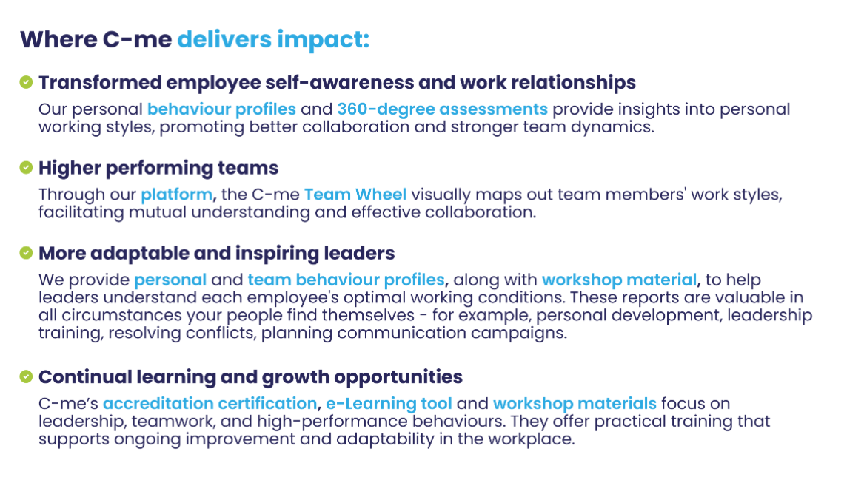
Could you create a more attractive visual of this with icons please?

FAQs
- How is your assessment validated?
Download our validation report here.
- What is your pricing?
Contact our Sales Team to discuss our pricing for your business.
- How quickly can we roll out C-me in our organisation?
We will work hard to fit to your timelines. The quickest option is for you to bring in a qualified C-me consultant. Please see our Solution Partner Directory for our trusted partners (insert link). You can also choose to gain a qualification and get yourself and your team accredited to deliver C-me in your organisation: we run accreditation courses every 4-6 weeks (taking place over two successive days). On completion of the course, you can roll out C-me immediately.
- Can I view a sample report?
Yes, of course, download one here: insert link.

Why people love C-me

Include testimony matrix

Whether you’re a global brand, Fortune 500 organisation, nonprofit, or startup, C-me is tailored to fit teams of any size.
If you would like to discuss how we can help your business, book a call with us.

CTA: Book a call

Please include a carousel with links to all other competitor pages

