Webpage: Looking for an alternative to Insights?

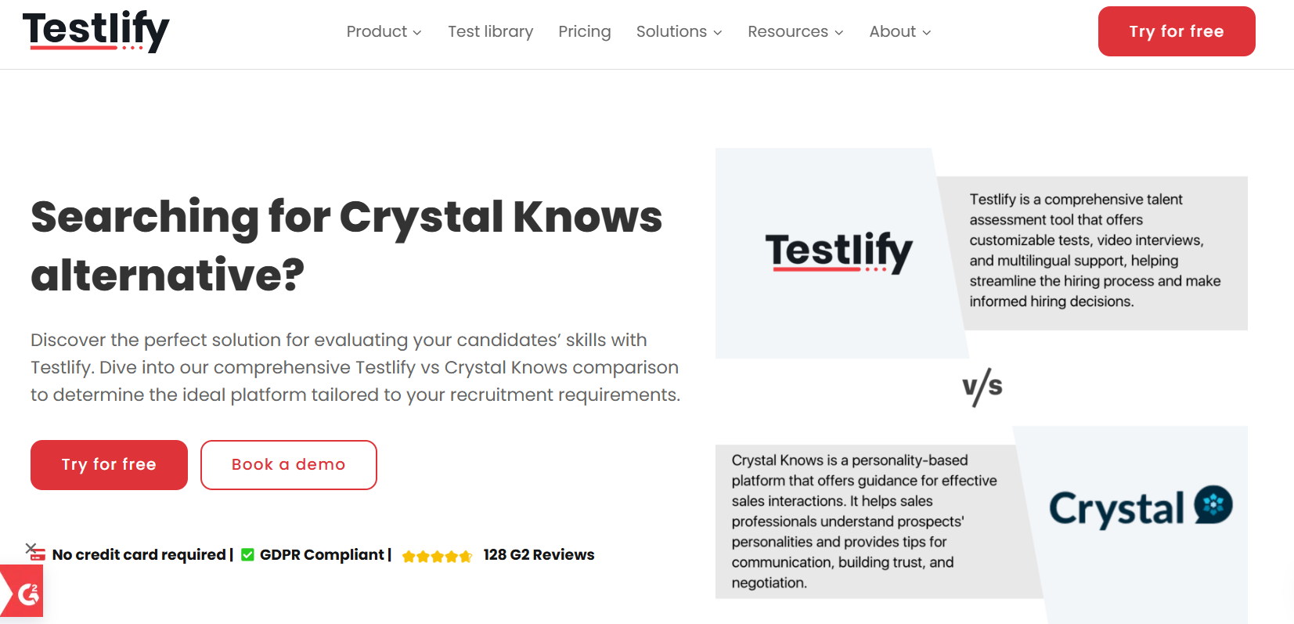
Insert Book a call and download a sample profile CTAs in hero

Copy for this hero image:
C-me: C-me offers one of the most personalised and cost-effective approaches to personal, team and organisational development in the learning and development space. We have shifted the focus of workplace psychometric tools from fixed ‘personality types’ to a more useful focus on ‘adaptable behaviours’. C-me is designed for practical application in busy working environments.
Insights: ​Insights Discovery is also a psychometric tool aimed at helping individuals comprehend their own behavioural preferences and those of others. They also focus on personal development, teamwork and leadership development. Their option is more expensive and less flexible for clients and partners.

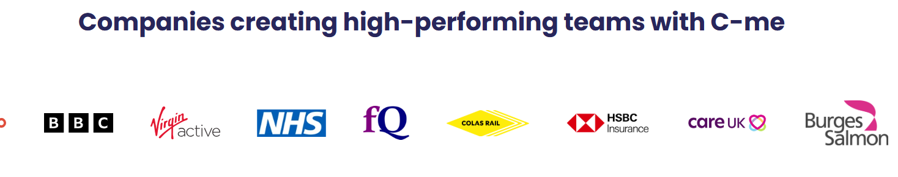

Why look for an Insights Discovery alternative?

Please put the below text next to the below ‘Accreditation costs’ graphic and replace the £4k+ number (in the bar chart) with something that just says thousands. Please replace the “free” above the C-me blue bar with (“Far cheaper” and make the blue band a bit fatter, to suggest we do have a cost but it’s much less.

Cost. User experience. Customer service.
Insights Discovery has higher upfront and ongoing costs and is less effective in its application. In contrast, C-me is designed to be more cost-effective, user-friendly, and faster to onboard in busy working environments.
Insights charge thousands to get accredited and offer two week courses in expensive venues. On top of this, they charge an ongoing licensing fee.
C-me charge far less to get accredited, offer a two day intensive accreditation course and no ongoing lincensing fee. We also offer better customer service – so we’re more available and treat you like a partner.
Try C-me out and you won’t want to leave.

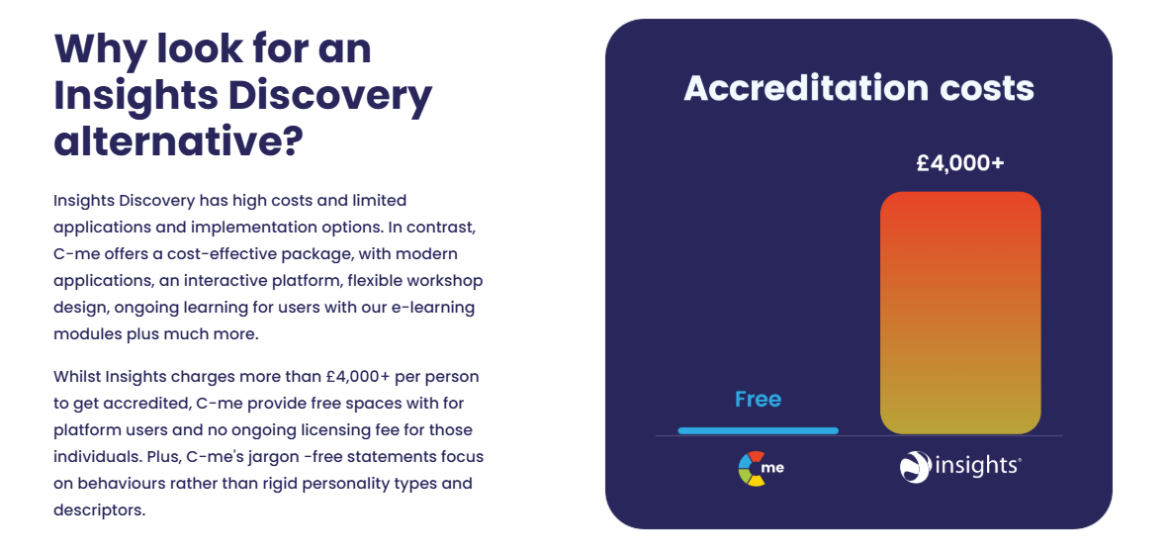

[Client testimony]

I have done Insights previously and was interested to see the difference (if there would be one) and would definitely recommend C-me as the preferred tool, due to its strong emphasis on not putting people in boxes! Love the terms 'Flex' and 'Blend' which I think prevent the less positive feelings from people who aren't as enthusiastic around tools such as these. I really enjoyed the accreditation and would highly recommend. Ellie Wood, INSERT HER ROLE Seasalt

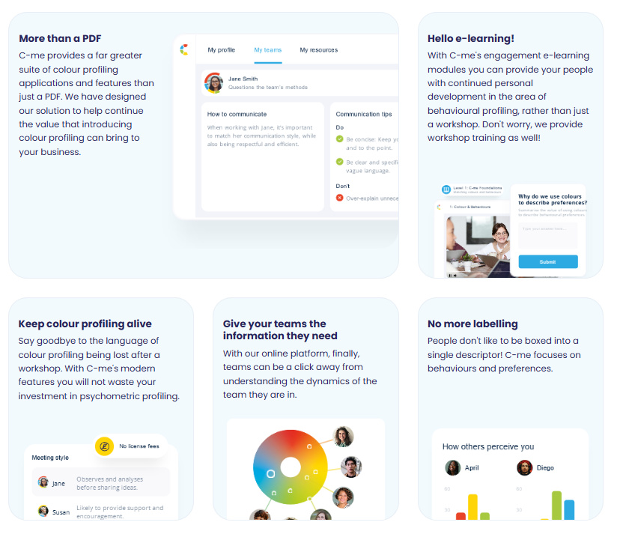
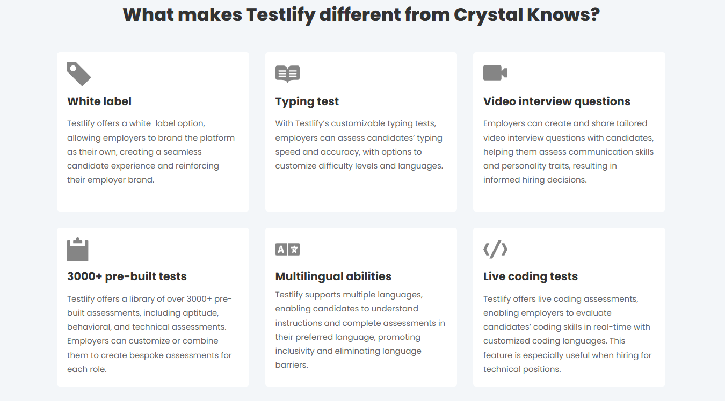

Please turn these points in to something that looks like the above graphics

What makes C-me different from Insights?

- More cost-effective – Cheaper to get accredited and no ongoing accreditation licensing fee, simpler pricing and no add-ons (Daniel have I described the pricing for client correctly? What about the ongoing subscription fee?)
- Quicker to get accredited – Our accreditation is just as effective and quicker to complete. It’s faster for you and your team to roll-out C-me and reap the benefits.
- No more labelling – No one likes to be boxed into a single descriptor. We are more complex and we need a tool to more accurately reflect how we change at work. C-me focuses on how a person’s behaviours and preferences flex in different circumstances. We reveal when this might happen and how to plan for it.
- Faster to learn and more memorable – There is no need to master a complex system in order to remember your own profile and even those of everyone you’re working with. C-me can bring teams together from day one in any industry and context, because it’s designed to be faster to learn and effective immediately.
- Take charge of how you use C-me - Add your brand on the assessment, on the report, on the platform, on the workshop material. Take the C-me material and integrate it into your existing tools. We provide the tools for you to make it work for you.
- A more user-friendly, interactive platform for all C-me activity - view your report, tailor it, share it, and view the team wheels you’re a part of, work through coaching questions, and prepare for meetings by viewing the reports of anyone in your organisation. Access our e-Learning tool and app add-ins. One place to access C-me.
- Better customer service – We’re here to help make your business work by making the most of your number one asset – your people. We schedule quarterly business reviews to flesh out your needs and ensure you’re getting ongoing value from C-me to hit your targets.
- Jargon free statements – We use more updated language and so that our reports speak directly to the user. You can even select your preferred pronoun.
Client quote “The C-me language is much more updated, the reports feel like they’re having a conversation with you!” Chris Duncan-Scott, Director and Learning Lead at Acceler8

How C-me and Insights’ psychometric tools compare

How Insights represent a person’s profile visually:

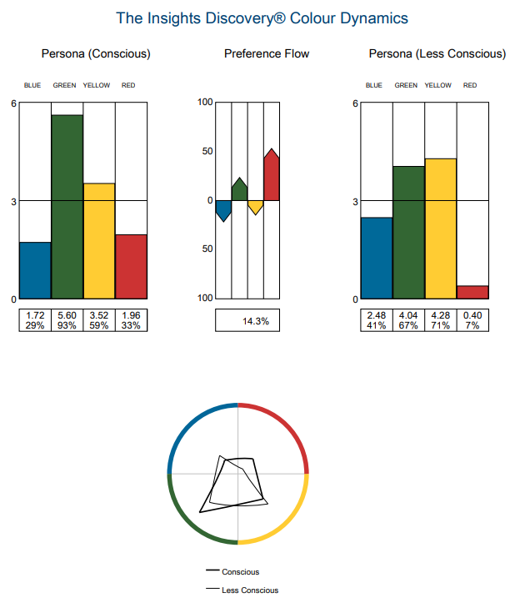
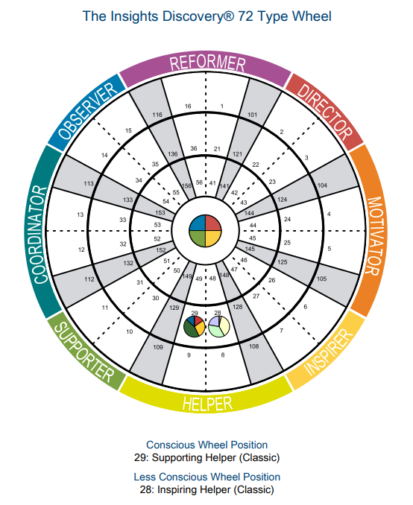

Insights team profile:
XXXXXXXXXXXXXXXXXXXXX

How C-me represent a person’s profile visually:

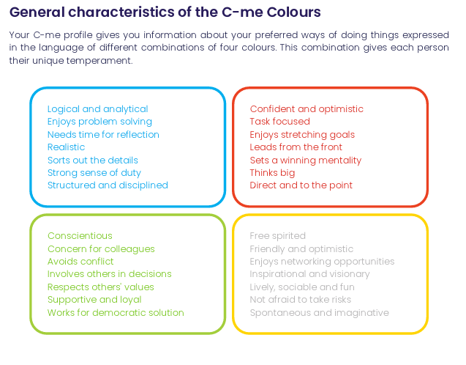
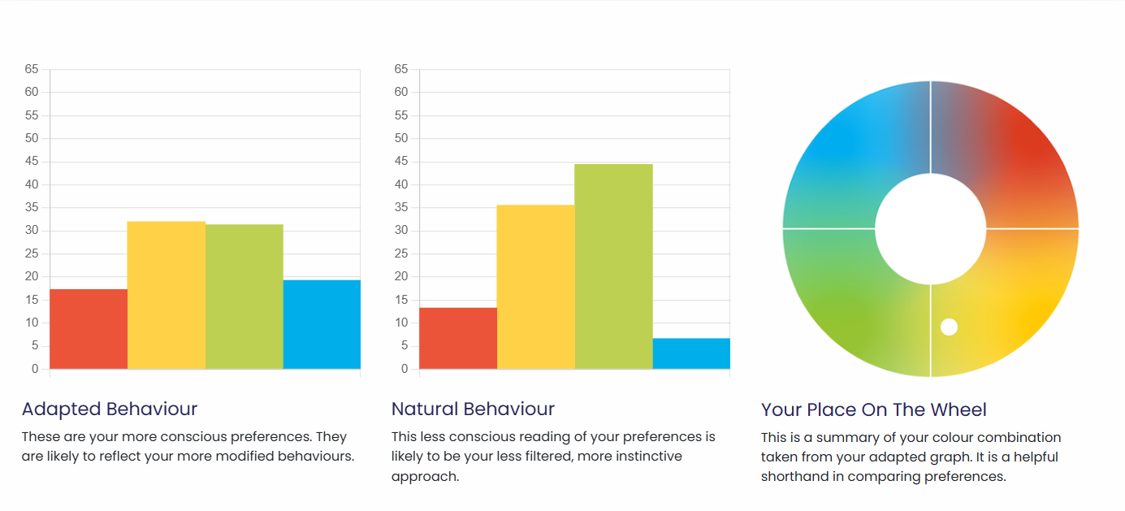
C-me team profile:
Insert sample team wheel

What are the similarities:
- Both are based on Jungian psychology.
- Application of colour to Jungian quadrants​ and both use a colour wheel and bar graphs.
- Both use preference indicators​ in the questionnaire – i.e. we ask people to rate themselves and their own preference.
- Both include a conscious and unconscious measure.
- Suitable for individuals, teams and organisations.
- Both focus on self-awareness, team dynamics, and leadership to build healthier organisations and drive business results.

What are the differences:

C-me represent data more simply. We cut out everything that is not essential to be clear, effective and increase the up-take.
You’ll notice within our wheel that colours are blended, without rigid divisions or numbers. We stripped off numbers, letters or strict categories to reflect that we are each a combination of all four colours. Unlike Insights, we don’t ask responders to remember numbers and their according categories. Instead, we simply encourage people to learn the four colours of the wheel and what they stand for. We ask that users simply remember their top two preferred colours. A person’s profile is not stuck to one inflexible category. We do not box people in. we encourage flexibility and growth. This emphasises that none of us are one static category, we flex between colours depending on the circumstances we’re in.
We also provide a simple C visual, that displays the colour order of a person’s preferences, as memorable icon to display and show others their colour preferences simply:



CTA: Take a 3 min tour of C-me

Client testimonial
“Getting busy people working in a client driven commercial environment to free up time for their CPD is pivotal, and where C-Me is worth its weight is in how accessible and colloquial it is. It allows us to use it as a shared language (and subsequent understanding) to improving collaboration by understanding each other's preferences.” Gavin XXX from Burgess Salmon

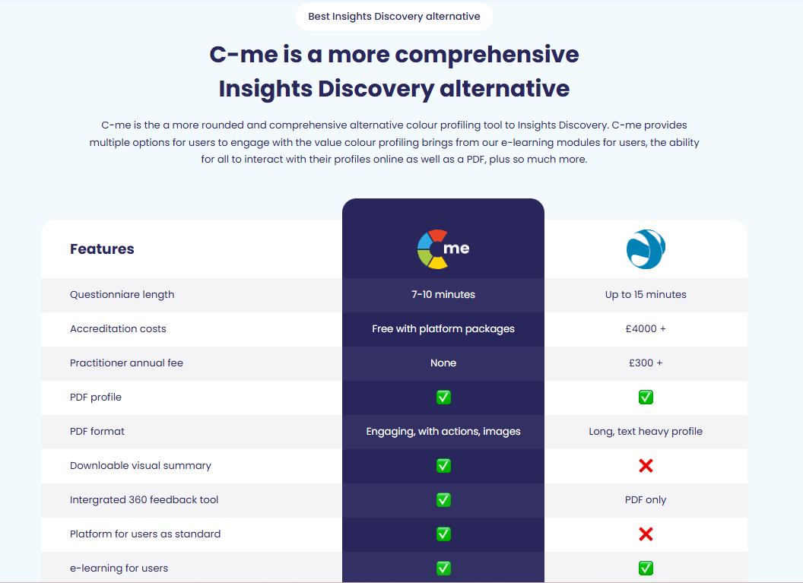
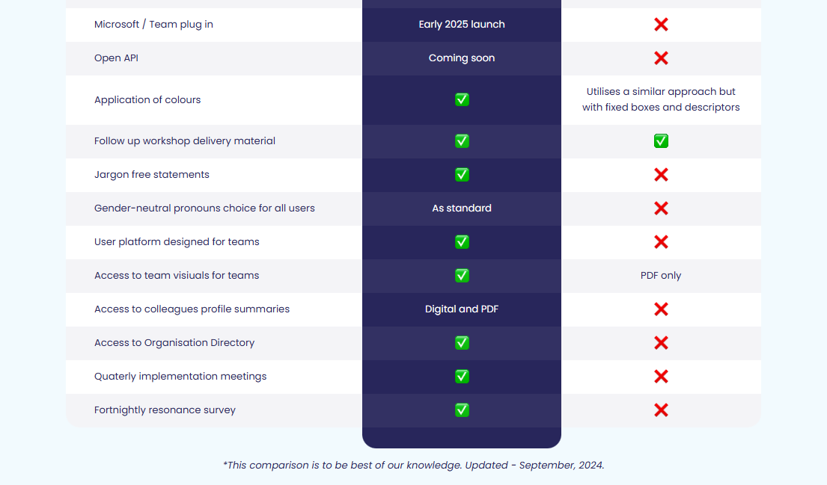
Please update the above table from this document: C-me vs Insights comparison table

Client testimonies of C-me’s accreditation

I would definitely recommend the accreditation. It was delivered in a clear, concise and friendly way that was easy to understand. There was room for discussion and time to reflect which was really valuable.- Claudia Shaw- The Kings Trust
Fun, easy to understand, flexible/ adaptable tool to many purposes, inclusive approach- Stephanie Lascaud- Q5
We have developed a short, intensive accreditation, spread over two successive half-days. It’s designed to be fun and accessible. To get you and your team up to speed, fast.

Where C-me delivers impact
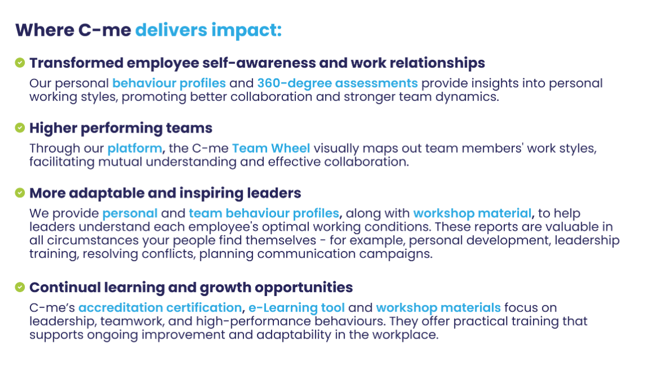
Could you create a more attractive visual of this with icons please?

FAQs
- How is your assessment validated?
Download our validation report here.
- What is your pricing?
Contact our Sales Team to discuss our pricing for your business.
- How quickly can we roll out C-me in our organisation?
We will work hard to fit to your timelines. The quickest option is for you to bring in a qualified C-me consultant. Please see our Solution Partner Directory for our trusted partners (insert link). You can also choose to gain a qualification and get yourself and your team accredited to deliver C-me in your organisation: we run accreditation courses every 4-6 weeks (taking place over two successive days). On completion of the course, you can roll out C-me immediately.
- Can I view a sample report?
Yes, of course, download one here: insert link.

Why people love C-me

Include testimony matrix

Whether you’re a global brand, Fortune 500 organisation, nonprofit, or startup, C-me is tailored to fit teams of any size.
If you would like to discuss how we can help your business, book a call with us.

CTA: Book a call

Please include a carousel with links to all other competitor pages

