Webpage: Looking for an alternative to Lumnia Learning?

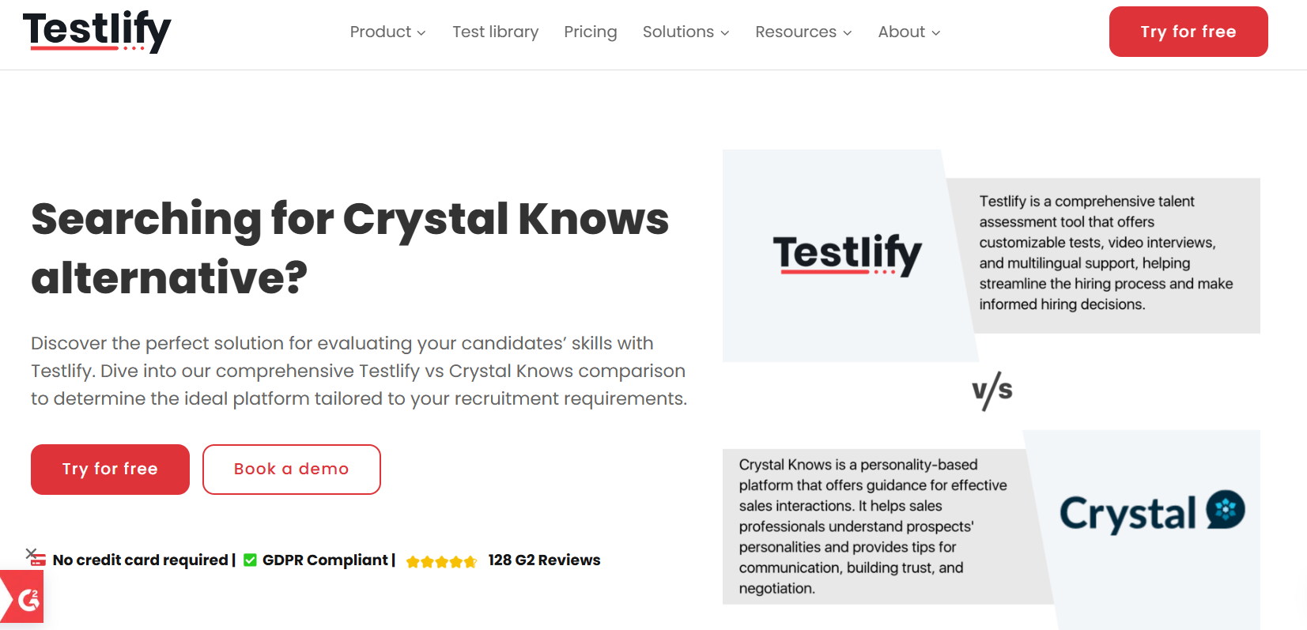
Insert Book a call and download a sample profile CTAs in hero

Copy for this hero image:
C-me: C-me offers one of the most user-friendly and cost-effective approaches to personal, team and organisational development in the learning and development space. C-me is designed for practical application in busy working environments.
​Lumina Learning: Lumina Learning is a psychometric assessment provider that offers tools for personal and professional development. Its primary product, Lumina Spark, evaluates individuals across 72 personality traits and three personas—Underlying, Everyday, and Overextended— they avoid categorical labels to provide a nuanced understanding of behaviour in various contexts.

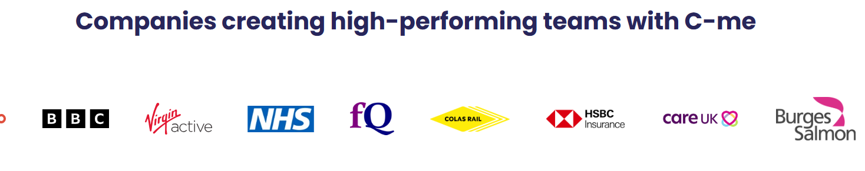

Why look for a Lumina Learning alternative?

User experience. Purpose.
C-me Colour Profiling stands out as a more practical and accessible alternative to Lumina Learning, especially for organisations looking to improve communication, collaboration, and performance quickly and effectively. While Lumina offers a more complex psychological assessment, C-me focuses on observable behaviours through a clear, four-colour model that teams can easily understand and apply without specialist knowledge. The simplicity of C-me makes it ideal for real-time development, from onboarding to leadership training, delivering immediate value without sacrificing depth. For L&D professionals seeking a user-friendly, engaging, and action-oriented tool, C-me offers a faster route to insight and impact.

[Client testimony]

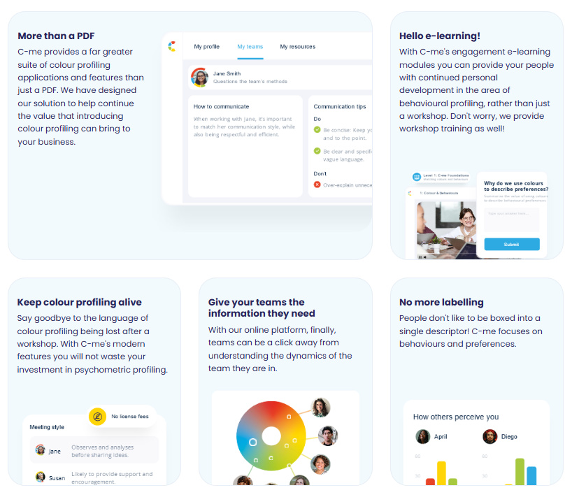
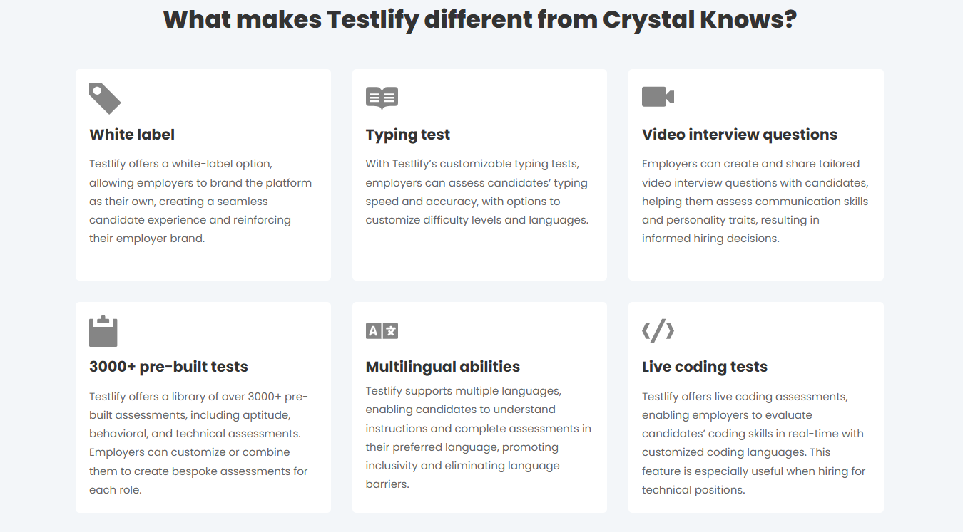

Please turn these points in to something that looks like the above graphics

What makes C-me different from Lumina Learning?

- Faster to learn and more memorable – There is no need to master a complex system in order to remember your own profile and even those of everyone you’re working with. C-me can bring teams together from day one in any industry and context, because it’s designed to be faster to learn and effective immediately.
- Take charge of how you use C-me - Add your brand on the assessment, on the report, on the platform, on the workshop material. Take the C-me material and integrate it into your existing tools. We provide the tools for you to make it work for you.
- A more user-friendly, interactive platform for all C-me activity - view your report, tailor it, share it, and view the team wheels you’re a part of, work through coaching questions, and prepare for meetings by viewing the reports of anyone in your organisation. Access our e-Learning tool and app add-ins. One place to access C-me.
Client quote “The C-me language is much more updated, the reports feel like they’re having a conversation with you!” Chris Duncan-Scott, Director and Learning Lead at Acceler8

How C-me and Lumina Learning’s psychometric tools compare

Samples of how Lumina Learning represent a person’s profile visually:

Download a sample report: Sample Lumnia Learning Spark Portrait
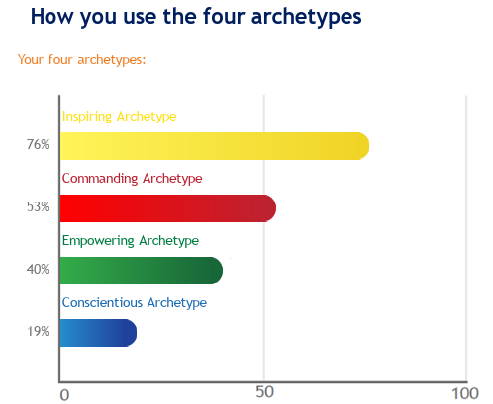
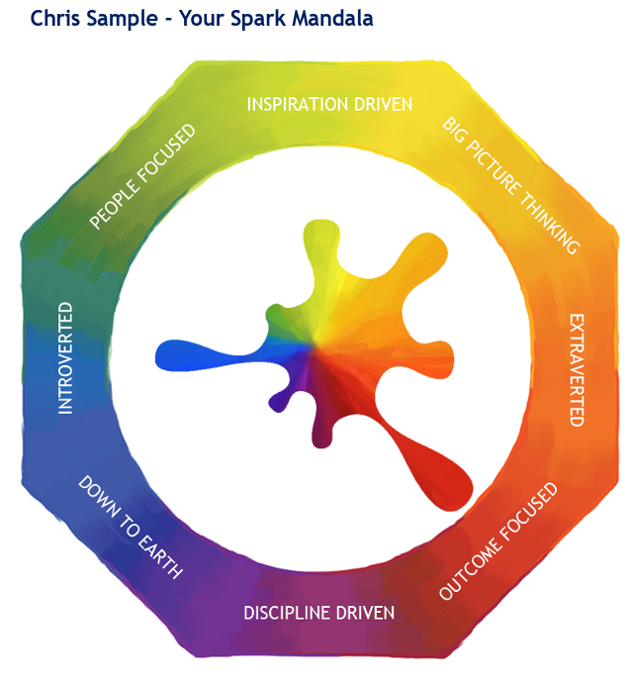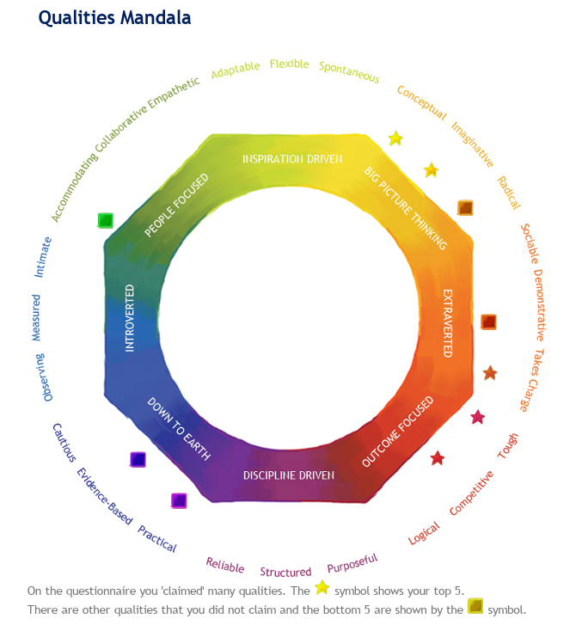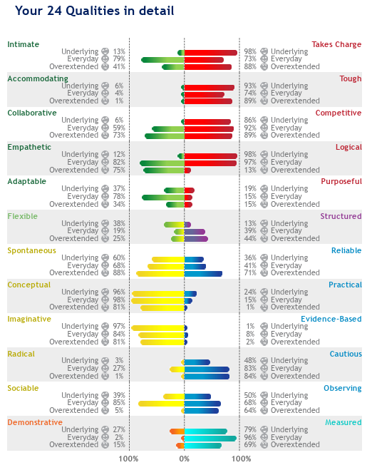

Lumina Learning team profile:
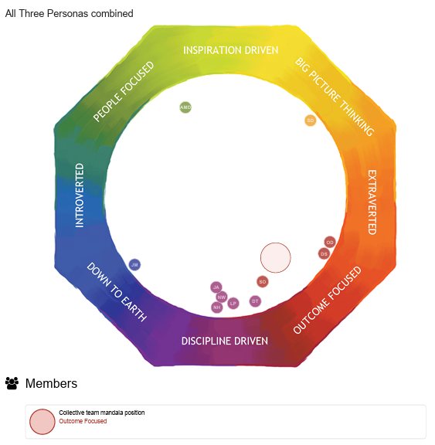

How C-me represent a person’s profile visually:

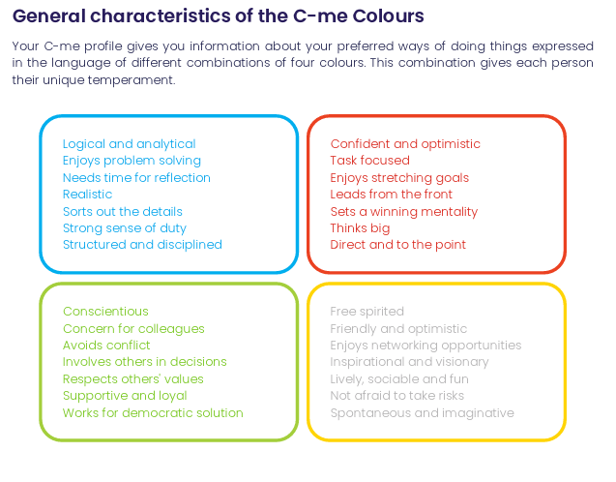
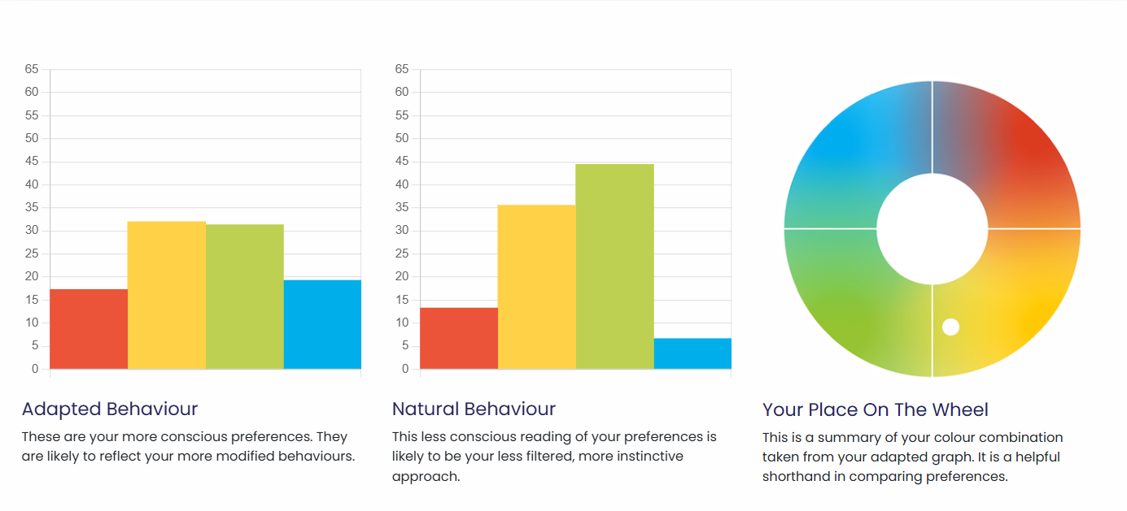

C-me team profile:
Insert sample team wheel
Download a sample report: Sample C-me High Performance report

What are the similarities:
- Both use preference indicators​ – i.e. we ask people to rate themselves and their own preference.
- Suitable for individuals, teams and organisations.
- Both focus on self-awareness, team dynamics, and leadership to build healthier organisations and drive business results.

What are the differences:

C-me represent data more simply. We cut out everything that is not essential, in order to be clear, effective and increase the up-take.
We don’t ask responders to remember extensive categories for themselves and then every team member they work with. Instead, we simply encourage people to learn the four colours of the wheel and what they stand for. We ask that users simply remember their top two preferred colours. A person’s profile is not stuck to one inflexible category. We do not box people in. We encourage flexibility and growth.
We also provide a simple C visual, that displays the colour order of a person’s preferences, as memorable icon to display and show others their colour preferences simply:



CTA: Take a 3 min tour of C-me

Client testimonial
“Getting busy people working in a client driven commercial environment to free up time for their CPD is pivotal, and where C-Me is worth its weight is in how accessible and colloquial it is. It allows us to use it as a shared language (and subsequent understanding) to improving collaboration by understanding each other's preferences.” Gavin XXX from Burgess Salmon

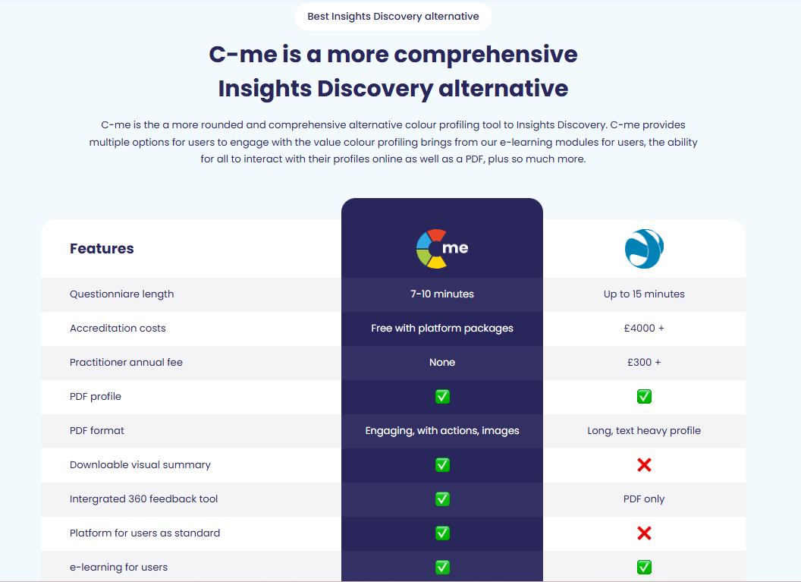
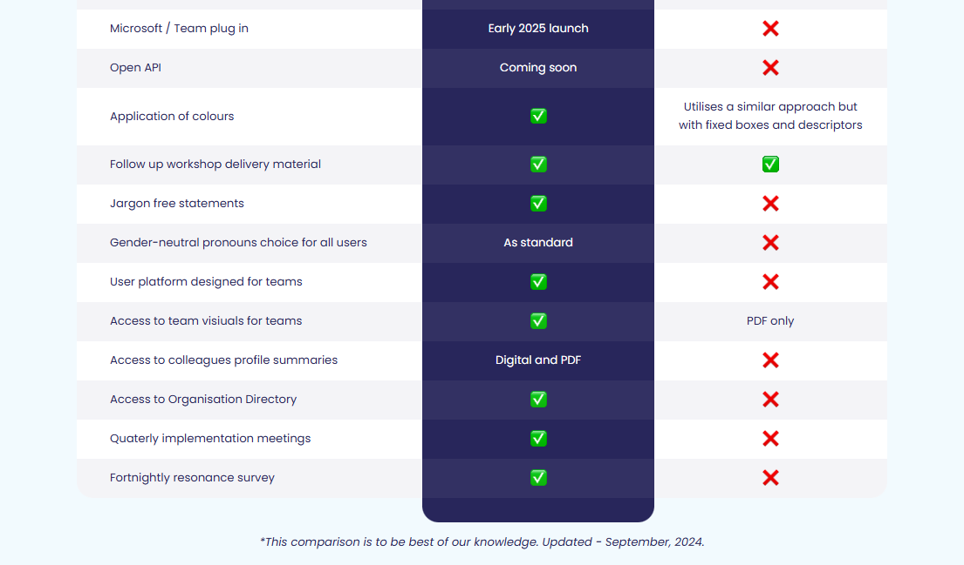
Please update the above table from this document: competitor comparison table.xlsx

Client testimonies of C-me’s accreditation

I would definitely recommend the accreditation. It was delivered in a clear, concise and friendly way that was easy to understand. There was room for discussion and time to reflect which was really valuable.- Claudia Shaw- The Kings Trust
Fun, easy to understand, flexible/ adaptable tool to many purposes, inclusive approach- Stephanie Lascaud- Q5
We have developed a short, intensive accreditation, spread over two successive half-days. It’s designed to be fun and accessible. To get you and your team up to speed, fast.

Where C-me delivers impact
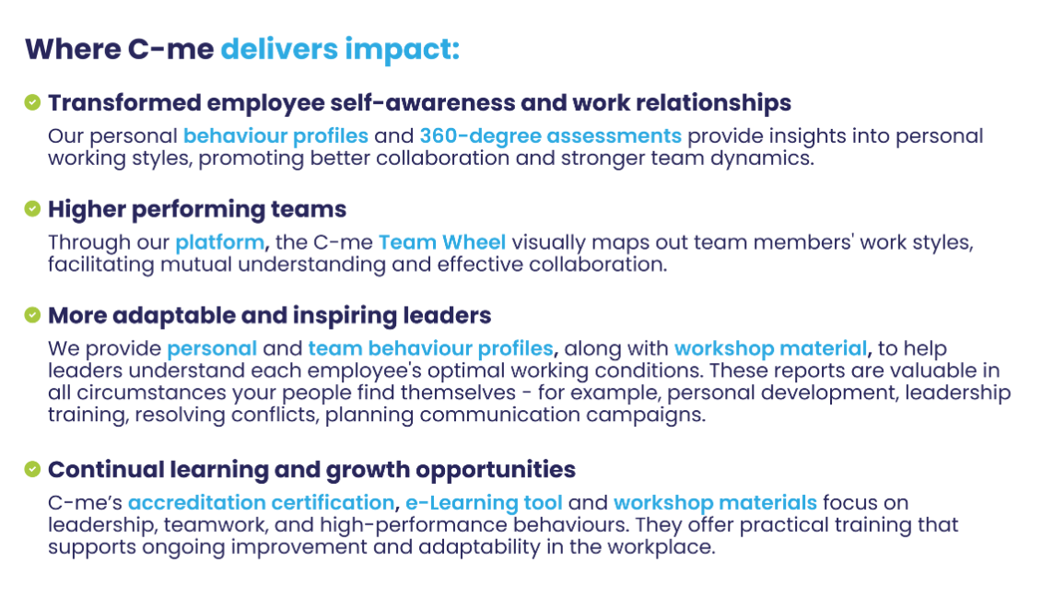
Could you create a more attractive visual of this with icons please?

FAQs
- How is your assessment validated?
Download our validation report here.
- What is your pricing?
Contact our Sales Team to discuss our pricing for your business.
- How quickly can we roll out C-me in our organisation?
We will work hard to fit to your timelines. The quickest option is for you to bring in a qualified C-me consultant. Please see our Solution Partner Directory for our trusted partners (insert link). You can also choose to gain a qualification and get yourself and your team accredited to deliver C-me in your organisation: we run accreditation courses every 4-6 weeks (taking place over two successive days). On completion of the course, you can roll out C-me immediately.
- Can I view a sample report?
Yes, of course, download one here: insert link.

Why people love C-me

Include testimony matrix

Whether you’re a global brand, Fortune 500 organisation, nonprofit, or startup, C-me is tailored to fit teams of any size.
If you would like to discuss how we can help your business, book a call with us.

CTA: Book a call

Please include a carousel with links to all other competitor pages

