Webpage: Looking for an alternative to McQuaig?

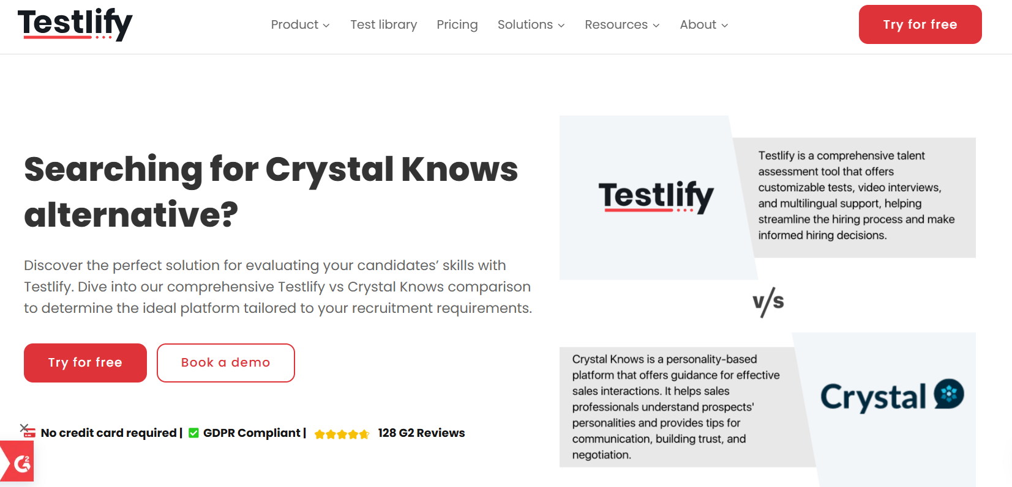
Insert Book a call and download a sample profile CTAs in hero

Copy for this hero image:
C-me: C-me offers one of the most user-friendly and cost-effective approaches to personal, team and organisational development in the learning and development space. Our tools focus on the ‘adaptable behaviours’ of a person, instead of fixed traits, making us much more useful in working environments.

McQuaig: McQuaig is a trait-based psychometric tool. Focused on predicting job fit and workplace behaviour, they use traditional behavioural descriptors and temperament analysis. Their tools have a more formal, text-heavy style.

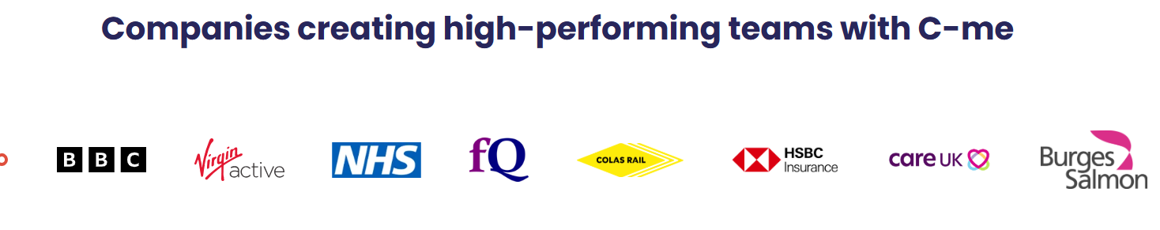

Why look for an alternative to McQuaig?

Purpose. User experience.
Whilst McQuaig’s reports offer valuable insights into candidates' personalities and cognitive abilities, their traditional, text-heavy approach can be less intuitive for broader employee engagement and ongoing personal development. For those looking for a tool that is more accessible, engaging, and faster to implement in to everyday workplace needs, C-me is the best alterantive. We take a more user-friendly, colour-based approach to understanding people. It is simple to understand, accurate and most crucially, much more memorable.

[Client testimony]

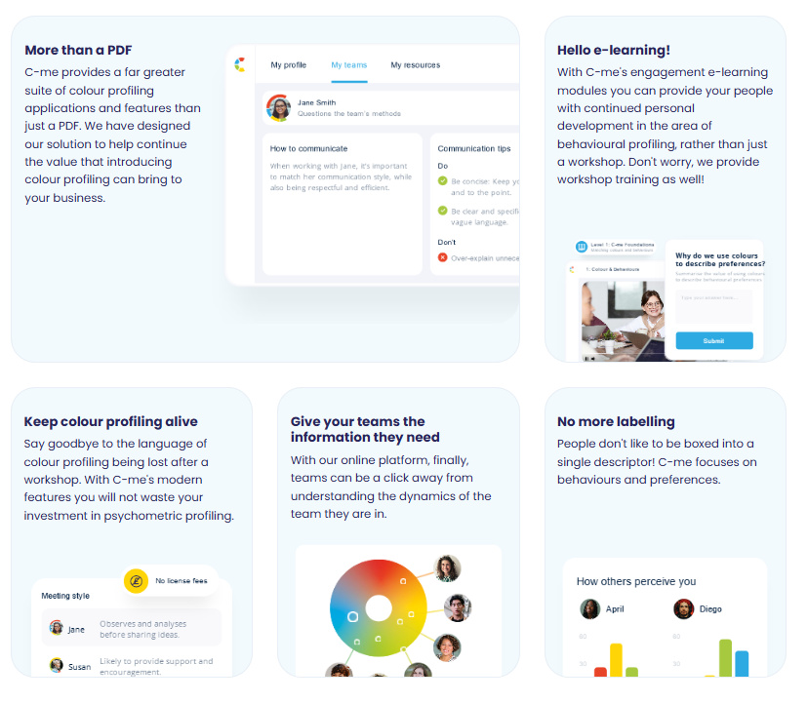
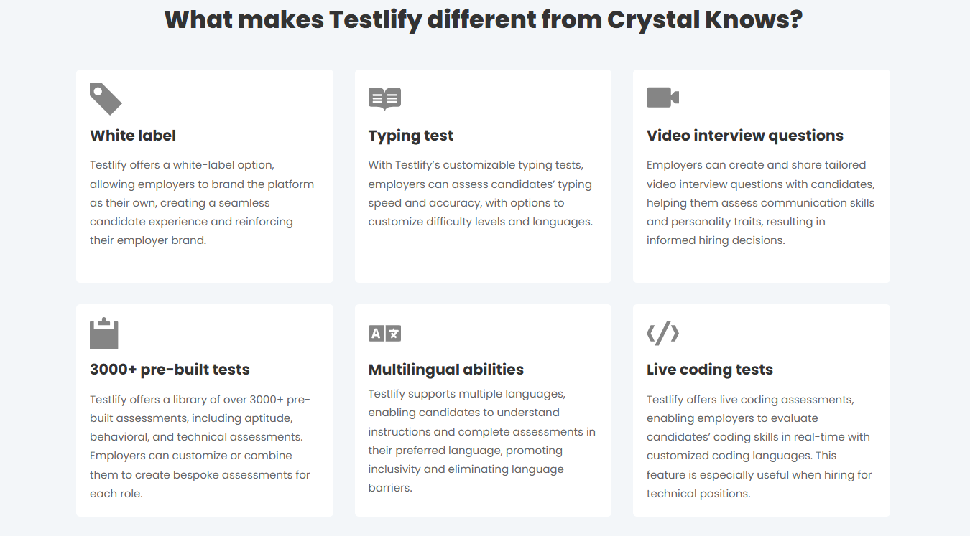

Please turn these points in to something that looks like the above graphics

What makes C-me different from McQuaig?

- Clearer, More Memorable Reporting: C-me's colour-coded profiling system—Red, Yellow, Green, Blue—makes profiles much easier to understand and recall. We also blend colours to show how people flex in different circumstances and to avoid boxing people in.
- Focussed on Flexibility and Growth: C-me highlights adaptable behaviours that can grow and evolve. This is a much more effective approach for personal, team and leadership development. We do not box people in to fixed traits or assess their cognitive abilities, which a person can do little to change.
- Clearer, More Inclusive Language: Our reports speak plainly, making them accessible for all. This builds inclusivity and quick understanding. Users can even select their preferred pronoun for their report.
- Better Tools for Team Dynamics: We plot out a better visual summary of team dynamics, (see below). We provide a more user-friendly and memorable way of helping teams understand themselves better and work more effectively together.
- More Efficient Assessments: The C-me assessment takes under 10 minutes but delivers an accurate report with practical, actionable insights.
- Take charge of how you use C-me - Add your brand on the assessment, on the report, on the platform, on the workshop material. Take the C-me material and integrate it into your existing tools. We provide the tools for you to make it work for you.

- Outlook Add-in – make is easier for your teams to communicate and collaborate with the C-me Outlook integration that embeds C-me learning into daily work.

Client quote “The C-me language is much more updated, the reports feel like they’re having a conversation with you!” Chris Duncan-Scott, Director and Learning Lead at Acceler8

How C-me and McQuaig’s compare visually

How McQuaig represent a person’s profile visually:

Dowload a sample report: McQuiag Sample Report self Development Survey

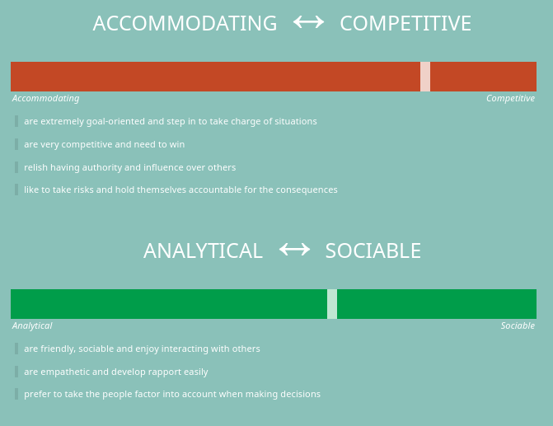
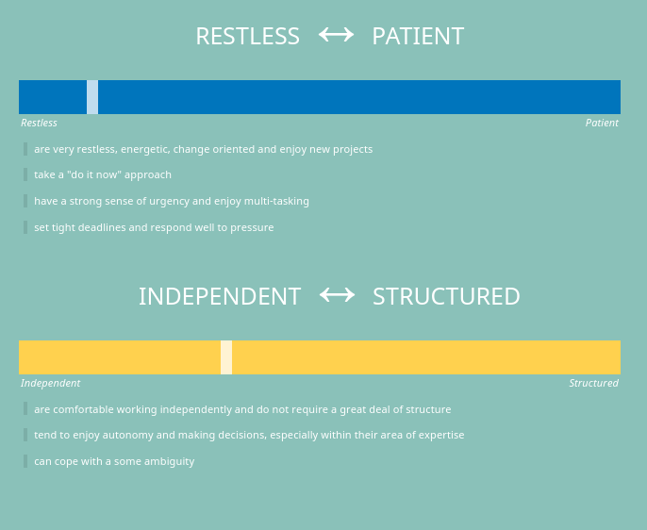
McQuaig’s team profile:
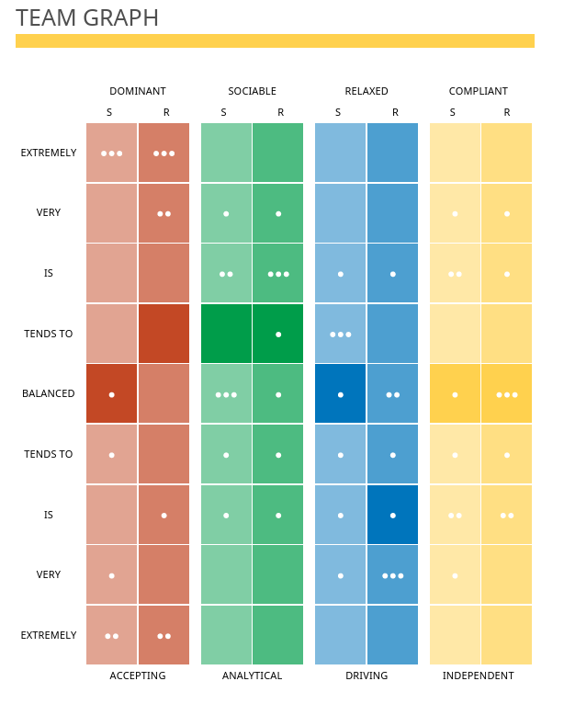

How C-me represent a person’s profile visually:

Download sample report: C-me Sample Report
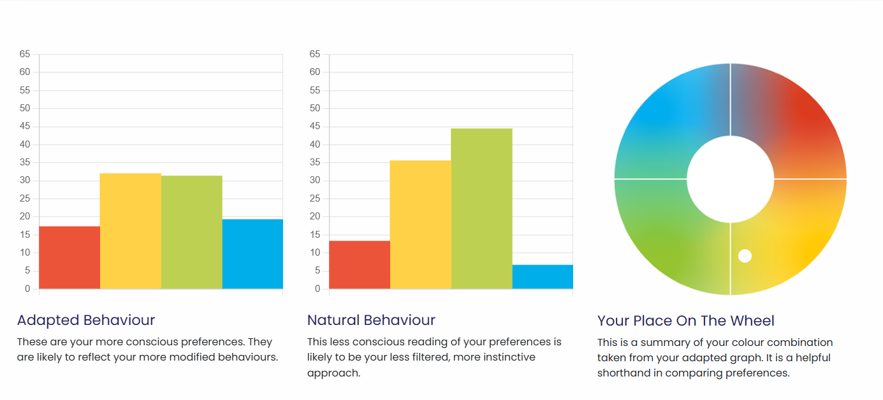
C-me tam profile:
Insert sample team wheel

What are the similarities:
- Suitable for individuals, teams and organisations.
- Both focus on self-awareness, team dynamics, and leadership to build healthier organisations and drive business results.

What are the differences:

C-me represent data more simply, in order to be clearer, more effective and increase the up-take.
Colours are an effective visual way of remembering behaviours and making it easier to integrate across teams and organisations.
We don’t ask responders to remember categories, with sliding scales, for themselves and then every team member they work with. Instead, we encourage people to learn the four colours of the wheel and the behaviours they stand for. We ask that users simply remember their top two preferred colours (because nobody is just one).
You’ll notice within our wheel that colours are blended, without rigid divisions or numbers. We stripped off numbers, letters or strict categories to reflect that we are each a combination of all four colours.
We also recognise change. We encourage flexibility and growth. This emphasises that none of us are one static category, we flex between colours depending on the circumstances we’re in. Our two graphs show our more conscious (adapted) behaviour and our less conscious (natural) behaviour. Giving a visual way to demonstrate how a person is adapting and what this might mean for them and their team.

To make it even simpler to integrate in to working life, provide a simple C visual, that displays the colour order of a person’s preferences, as a memorable icon to display and show others their colour preferences simply:

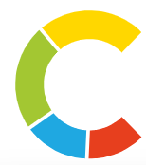

Our team wheel is a much more effective way of demonstrating the relationship between colleagues. It is a much clearer way to identify where colleagues sit on the wheel, instead of boxes.

CTA: Take a 3 min tour of C-me

Client testimonial
“Getting busy people working in a client driven commercial environment to free up time for their CPD is pivotal, and where C-Me is worth its weight is in how accessible and colloquial it is. It allows us to use it as a shared language (and subsequent understanding) to improving collaboration by understanding each other's preferences.” Gavin XXX from Burgess Salmon

Client testimonies of C-me’s accreditation

I would definitely recommend the accreditation. It was delivered in a clear, concise and friendly way that was easy to understand. There was room for discussion and time to reflect which was really valuable.- Claudia Shaw- The Kings Trust
Fun, easy to understand, flexible/ adaptable tool to many purposes, inclusive approach- Stephanie Lascaud- Q5
We have developed a short, intensive accreditation, spread over two successive half-days. It’s designed to be fun and accessible. To get you and your team up to speed, fast.

Where C-me delivers impact
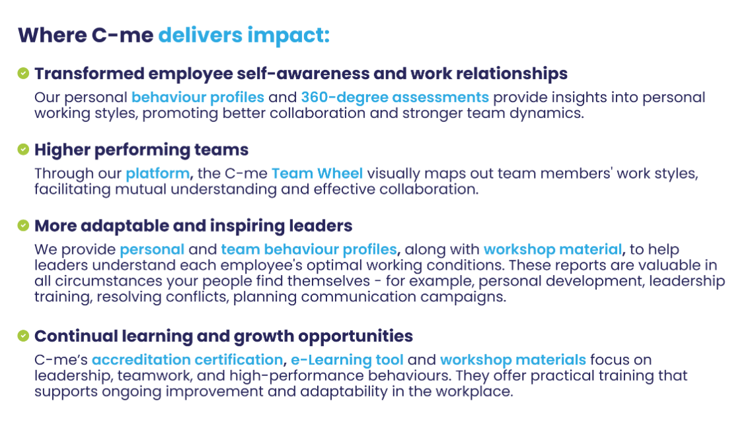
Could you create a more attractive visual of this with icons please?

FAQs
- How is your assessment validated?
Download our validation report here.
- What is your pricing?
Contact our Sales Team to discuss our pricing for your business.
- How quickly can we roll out C-me in our organisation?
We will work hard to fit to your timelines. The quickest option is for you to bring in a qualified C-me consultant. Please see our Solution Partner Directory for our trusted partners (insert link). You can also choose to gain a qualification and get yourself and your team accredited to deliver C-me in your organisation: we run accreditation courses every 4-6 weeks (taking place over two successive days). On completion of the course, you can roll out C-me immediately.
- Can I view a sample report?
Yes, of course, download one here: insert link.

Why people love C-me

Include testimony matrix

Whether you’re a global brand, Fortune 500 organisation, nonprofit, or startup, C-me is tailored to fit teams of any size.
If you would like to discuss how we can help your business, book a call with us.

CTA: Book a call

Please include a carousel with links to all other competitor pages

