Webpage: Looking for an alternative to The Big Five Model?

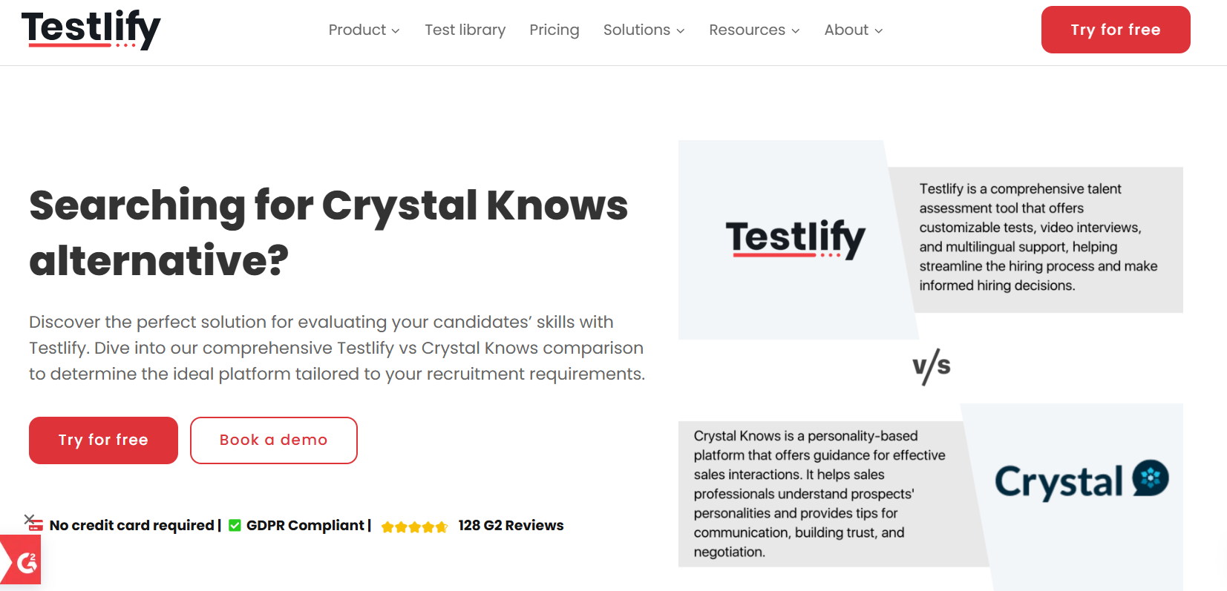
Insert Book a call and download a sample profile CTAs in hero

Copy for this hero image:
C-me: C-me offers one of the most personalised and cost-effective approaches to personal, team and organisational development in the learning and development space. We have shifted the focus of workplace psychometric tools from fixed ‘personality types’ to a more useful focus on ‘adaptable behaviours’. C-me is designed for practical application in busy working environments.
Big Five Model: ​​The Big Five personality model, also known as the Five-Factor Model, is a framework in psychology that categorises human personality into five broad dimensions: Openness, Conscientiousness, Extraversion, Agreeableness, and Neuroticism. The Big Five model is much more suited to academic contexts.

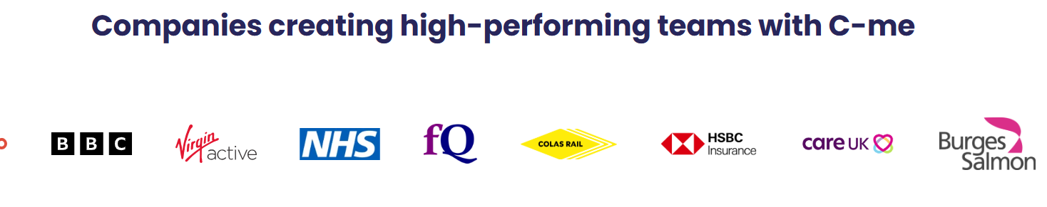

Why look for a Big Five Model alternative?

User experience. Customer service.
The Big Five personality model is more suited for academic research, psychological assessments and contexts where depth is most important. It requires a long questionnaire and delivers a detailed view of personality traits. In contrast, C-me shines in professional and organisational settings. We provide a much more intuitive approach, facilitating quick understanding and intregration - with a shorter questionnaire and more applicable reports that focus on the key skills of high performing individuals, teams and organisations - communication, motivations, team dynamics, and personal development with a simple colour-coded system.
There are many suppliers of the Big Five Model from online free tests to consultancies using the tool, so we will simply focus on the funtion of the tool in this comparison and the service that C-me can offer.

[Client testimony]

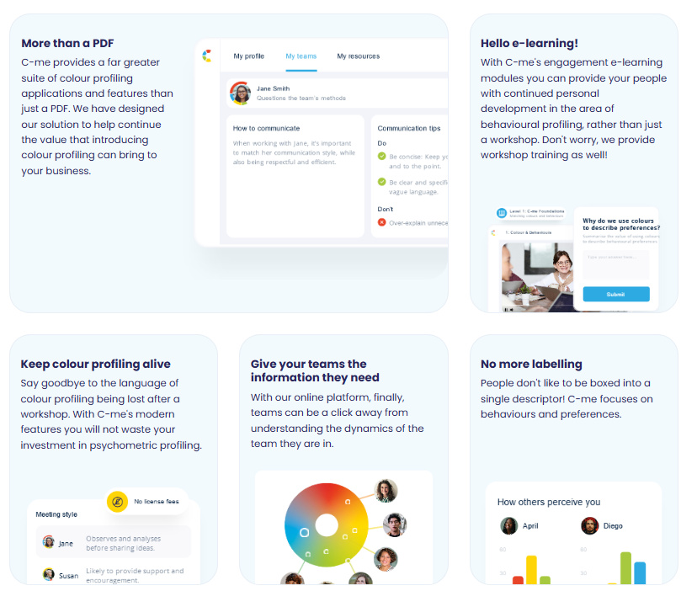
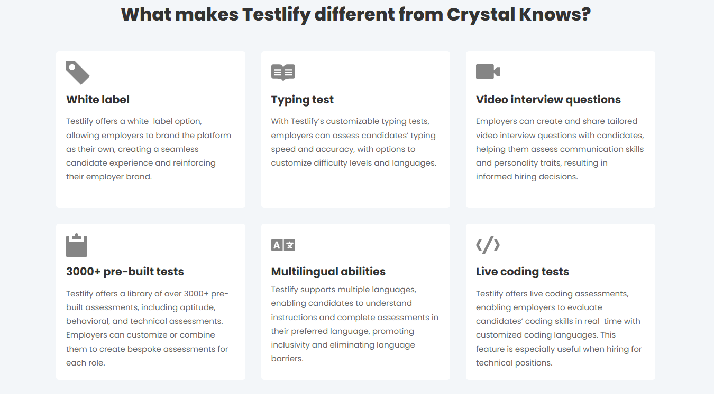

Please turn these points in to something that looks like the above graphics

What makes C-me different from the Big Five model?

- Faster to learn and more memorable – There is no need to master a complex system in order to remember your own profile and even those of everyone you’re working with. C-me can bring teams together from day one in any industry and context, because it’s designed to be faster to learn, be effective immediately, and provide ongoing value.
- More applicable to professional contexts – C-me is designed for business and organisations who want to build higher performing teams – our reports and workshops are succinct, engaging, and filled with coaching advice for personal development. We also provide data in various ways to map a whole team and organisation, providing alternative perspectives on your operations, recruitment planning, board level performance, change management planning, and more.
- Take charge of how you use C-me - Add your brand on the assessment, on the report, on the platform, on the workshop material. Take the C-me material and integrate it into your existing tools. We provide the tools for you to make it work for you.
- A user-friendly, interactive platform for all C-me activity - view your report, tailor it, share it, and view the team wheels you’re a part of, work through coaching questions, and prepare for meetings by viewing the reports of anyone in your organisation. Access our e-Learning tool and app add-ins. One place to access C-me.
- Customer service – We’re here to help make your business work by making the most of your number one asset – your people. We schedule quarterly business reviews to flesh out your needs and ensure you’re getting ongoing value from C-me to hit your targets.
- Jargon free statements – We use more updated language and so that our reports speak directly to the user. You can even select your preferred pronoun.
Client quote “The C-me language is much more updated, the reports feel like they’re having a conversation with you!” Chris Duncan-Scott, Director and Learning Lead at Acceler8

How C-me and The Big Five Models’ psychometric tools compare

Here are some of the ways suppliers of the Big Five represent a person’s profile visually:

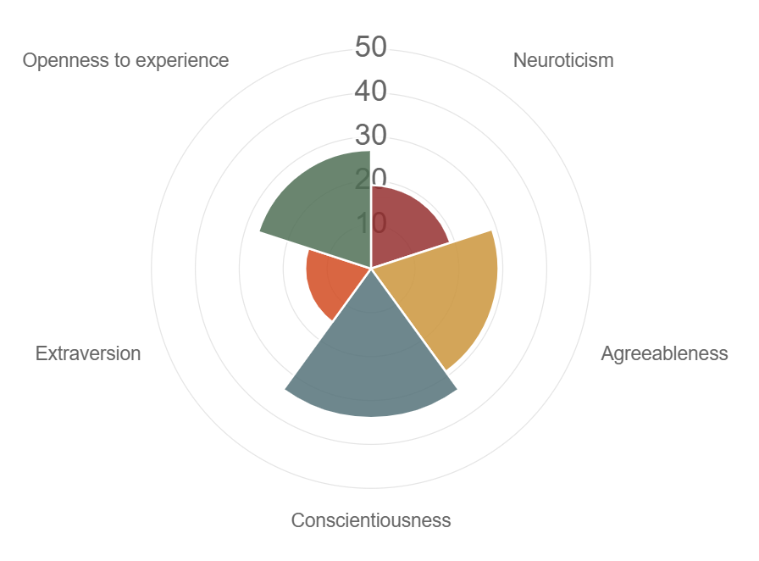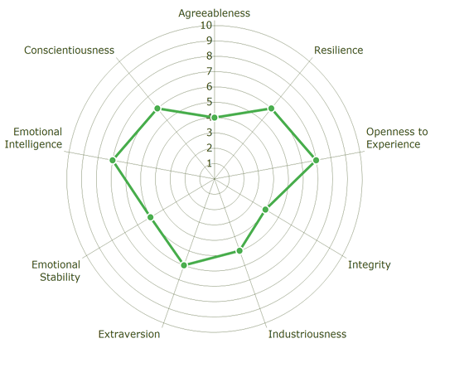
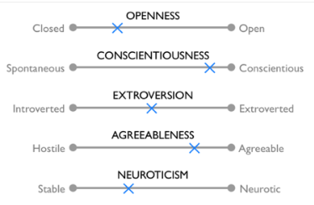

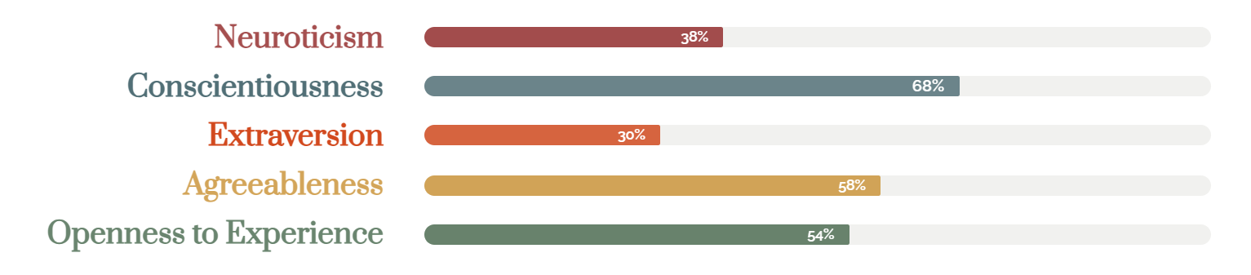

How C-me represent a person’s profile visually:

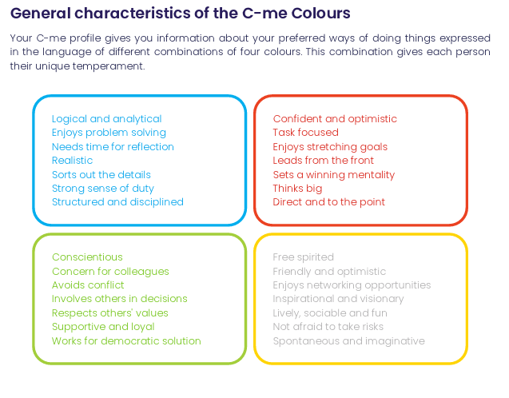
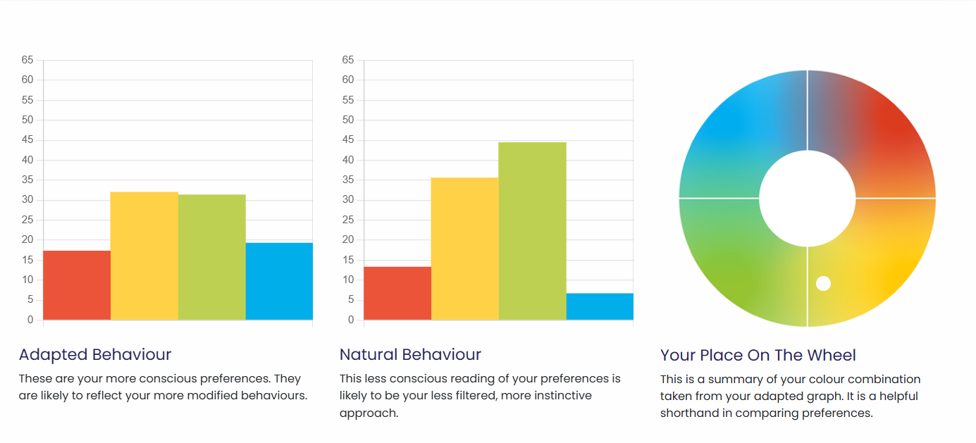

What are the similarities:
- Both measure traits in a scale rather than binary categories, such as introvert or extravert.

What are the differences:
The Big Five model reports are long, detailed and focus on various factors that are not the most applicable traits in the workplace. Their reports are much more data and text heavy. They are more difficult to remember, especially in a team with multiple reports.
C-me represent data more simply. We cut out everything that is not essential, in order to be clear, effective and increase the up-take.
The Big Five model approaches traits as relatively fixed throughout a person’s lifetime, apparently even suitable for predicting life outcomes. Our approach is different, we make room for development.

You’ll notice we use two bar graphs and a colour wheel. Our two graphs are designed to reflect both a person’s constant traits and their adaptable traits. C-me is a better way to plot the development of a person in their career and how to help them prepare for future roles and also reflect on historical performance at work.
We then plot a person’s conscious behaviour on to a colour wheel, as this is what most of us see of that person at work. The colours on the wheel are blended, without rigid divisions or numbers. We stripped off numbers, letters or strict categories to reflect that we are each a combination of all four colours. We don’t ask responders to remember numbers and their according categories. Instead, we simply encourage people to learn the four colours of the wheel and the behaviours they stand for. We ask that users simply remember their top two preferred colours. A person’s profile is not stuck to one inflexible category. We do not box people in. We encourage flexibility and growth. This emphasises that none of us are one static category, we flex between colours depending on the circumstances we’re in.
We also provide a simple C visual, that displays the colour order of a person’s preferences, as memorable icon to display and show others their colour preferences simply:



CTA: Take a 3 min tour of C-me

Client testimonial
“Getting busy people working in a client driven commercial environment to free up time for their CPD is pivotal, and where C-Me is worth its weight is in how accessible and colloquial it is. It allows us to use it as a shared language (and subsequent understanding) to improving collaboration by understanding each other's preferences.” Gavin XXX from Burgess Salmon

Client testimonies of C-me’s accreditation

I would definitely recommend the accreditation. It was delivered in a clear, concise and friendly way that was easy to understand. There was room for discussion and time to reflect which was really valuable.- Claudia Shaw- The Kings Trust
Fun, easy to understand, flexible/ adaptable tool to many purposes, inclusive approach- Stephanie Lascaud- Q5
We have developed a short, intensive accreditation, spread over two successive half-days. It’s designed to be fun and accessible. To get you and your team up to speed, fast.

Where C-me delivers impact
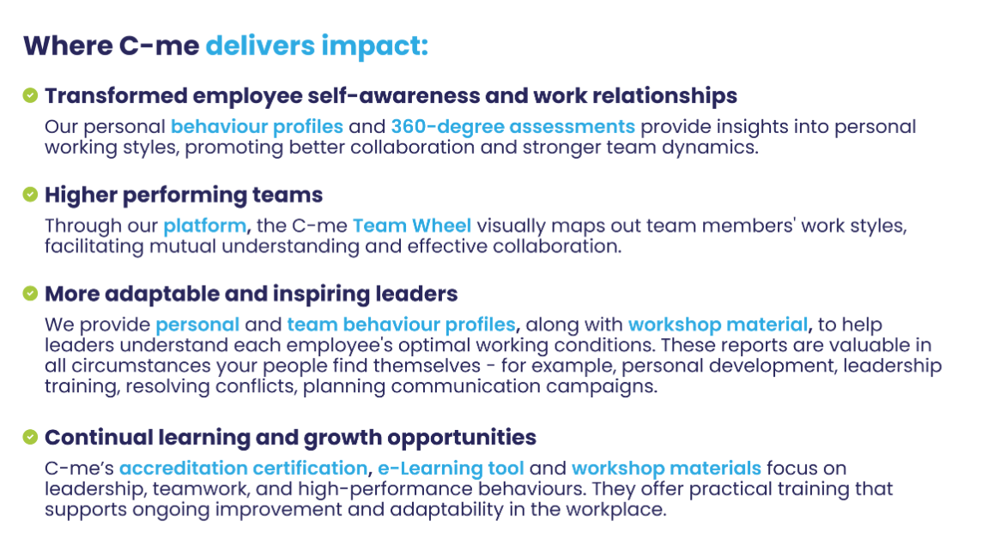
Could you create a more attractive visual of this with icons please?

FAQs
- How is your assessment validated?
Download our validation report here.
- What is your pricing?
Contact our Sales Team to discuss our pricing for your business.
- How quickly can we roll out C-me in our organisation?
We will work hard to fit to your timelines. The quickest option is for you to bring in a qualified C-me consultant. Please see our Solution Partner Directory for our trusted partners (insert link). You can also choose to gain a qualification and get yourself and your team accredited to deliver C-me in your organisation: we run accreditation courses every 4-6 weeks (taking place over two successive days). On completion of the course, you can roll out C-me immediately.
- Can I view a sample report?
Yes, of course, download one here: insert link.

Why people love C-me

Include testimony matrix

Whether you’re a global brand, Fortune 500 organisation, nonprofit, or startup, C-me is tailored to fit teams of any size.
If you would like to discuss how we can help your business, book a call with us.

CTA: Book a call

Please include a carousel with links to all other competitor pages

